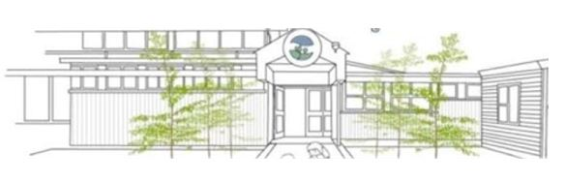

Enrolment at Riverdale School is governed by an enrolment scheme, details of which are available from the school office.
Our current home zone is: From the North East corner where Pitama Road intersects College Street and area bounded by Pitama Road East to Dittmer Drive including all streets off Pitama Road, except Sheffield Street North along Dittmer Drive to the intersection of Whikiriwhi Crescent then East to the Manawatu River, south along the Manawatu River to the Mangaone Stream, west along the Mangaone Stream then north in the straight line to 90 Maxwells Line, including all of Haast Place. North along the southern side of College Street to the Pitama Road intersection.
To be entered in the Out of Zone ballot please complete the Riverdale School Enrolment form which is available from the School office or can be downloaded from the Riverdale School website. We do require a copy of your child’s Birth Certificate to confirm child’s name and date of birth.
Applications for enrolment will be processed in the following order of priority.
Please tick which priority you meet:
First priority must be given to ORS students depending on space (determined by staffing levels for ORS)
Second priority must be given to any applicant who is the sibling of a current student of the school
Third priority must be given to any student who is the sibling of a former student of the school
Fourth priority must be given to any applicant who is a child of a former student of the school
Fifth priority must be given to any applicant who is either a child of an employee of the board of the school or a child of a member of the board of the school
Sixth priority must be given to all other applicants.

If you require any further information, please contact Tracey Phillips office@riverdale.school.nz.
Board of Trustees
Riverdale School
95 Slacks Road
P O Box 6093
Palmerston North 4412

